PROJECT

-– PRODUCTS
-- Basic Exploration PRODUCTS
------------------------------------------------------------
-- Preview first 10 rows
SELECT *
FROM SH.PRODUCTS
FETCH FIRST 10 ROWS ONLY;

OUTPUT
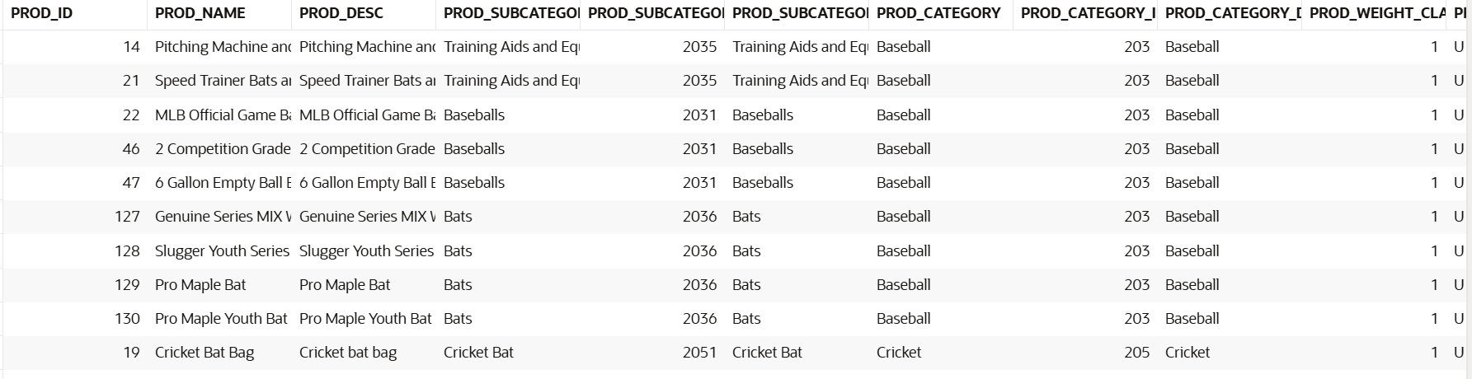

-- Count total products
SELECT COUNT(*) AS total_products
FROM SH.PRODUCTS;

OUTPUT
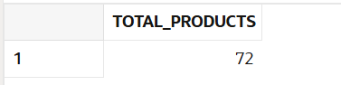

-- Count distinct product IDs
SELECT COUNT(DISTINCT PROD_ID) AS distinct_product_ids
FROM SH.PRODUCTS;

OUTPUT
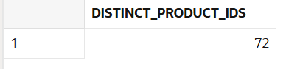

-- Products grouped by category
SELECT PROD_CATEGORY, COUNT(*) AS product_count
FROM SH.PRODUCTS
GROUP BY PROD_CATEGORY
ORDER BY product_count DESC;

OUTPUT
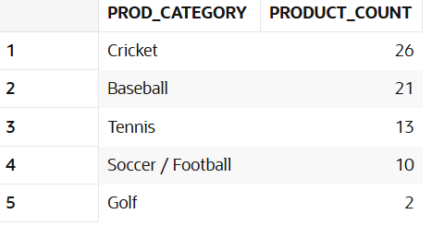

-- Products grouped by subcategory
SELECT PROD_SUBCATEGORY, COUNT(*) AS product_count
FROM SH.PRODUCTS
GROUP BY PROD_SUBCATEGORY
ORDER BY product_count DESC;

OUTPUT
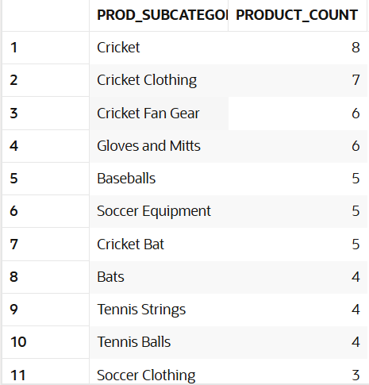
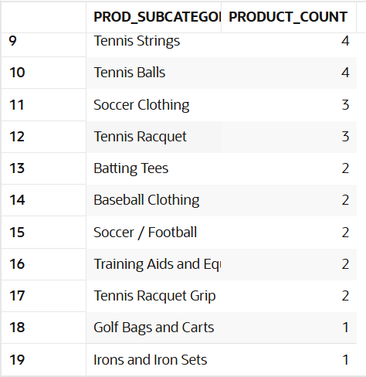

-- Check for missing values in key columns
SELECT
SUM(CASE WHEN PROD_NAME IS NULL THEN 1 ELSE 0 END) AS null_prod_name,
SUM(CASE WHEN PROD_CATEGORY IS NULL THEN 1 ELSE 0 END) AS null_prod_category,
SUM(CASE WHEN PROD_LIST_PRICE IS NULL THEN 1 ELSE 0 END) AS null_list_price,
SUM(CASE WHEN PROD_STATUS IS NULL THEN 1 ELSE 0 END) AS null_prod_status
FROM SH.PRODUCTS;

OUTPUT
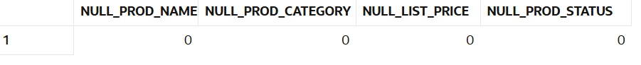

-- Insights
------------------------------------------------------------
-- Average price per category
SELECT PROD_CATEGORY, AVG(PROD_LIST_PRICE) AS avg_price
FROM SH.PRODUCTS
GROUP BY PROD_CATEGORY
ORDER BY avg_price DESC;

OUTPUT
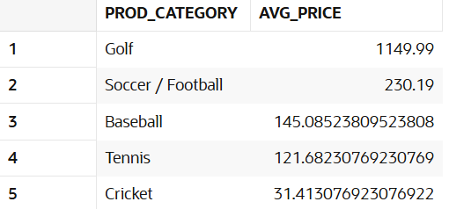

-- Top 10 most expensive products
SELECT PROD_ID, PROD_NAME, PROD_LIST_PRICE
FROM SH.PRODUCTS
ORDER BY PROD_LIST_PRICE DESC
FETCH FIRST 10 ROWS ONLY;

OUTPUT
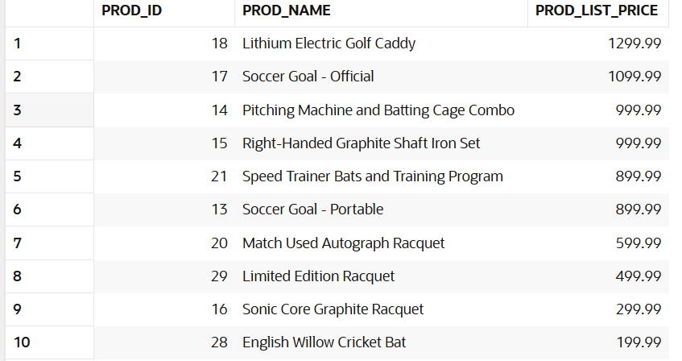

-- Products with largest gap between list price and minimum price
SELECT PROD_ID, PROD_NAME, PROD_LIST_PRICE, PROD_MIN_PRICE,
(PROD_LIST_PRICE - PROD_MIN_PRICE) AS price_gap
FROM SH.PRODUCTS
ORDER BY price_gap DESC
FETCH FIRST 10 ROWS ONLY;

OUTPUT
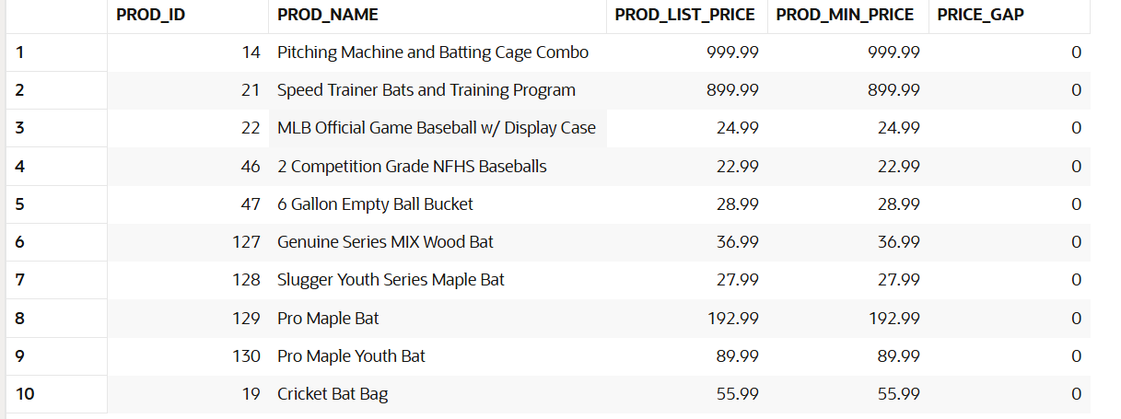

-- Relationships with Tables
------------------------------------------------------------
-- Sales by product category
SELECT p.PROD_CATEGORY, SUM(s.AMOUNT_SOLD) AS total_sales
FROM SH.SALES s
JOIN SH.PRODUCTS p ON s.PROD_ID = p.PROD_ID
GROUP BY p.PROD_CATEGORY
ORDER BY total_sales DESC;

OUTPUT
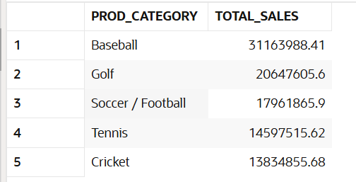

-- Average unit cost vs unit price by product
SELECT p.PROD_NAME, AVG(c.UNIT_COST) AS avg_cost, AVG(c.UNIT_PRICE) AS avg_price
FROM SH.COSTS c
JOIN SH.PRODUCTS p ON c.PROD_ID = p.PROD_ID
GROUP BY p.PROD_NAME
ORDER BY avg_price DESC;

OUTPUT
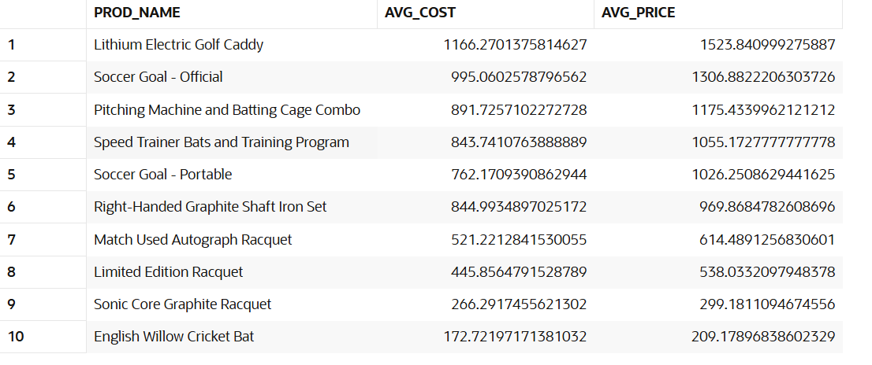

—- CUSTOMERS
-- Basic Exploration CUSTOMERS
------------------------------------------------------------
-- Preview first 10 rows
SELECT *
FROM SH.CUSTOMERS
FETCH FIRST 10 ROWS ONLY;

OUTPUT
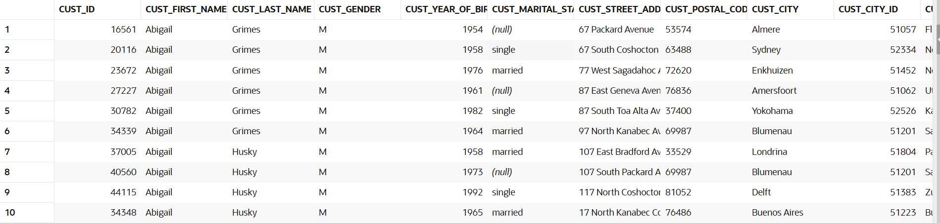

-- Count total customers
SELECT COUNT(*) AS total_customers
FROM SH.CUSTOMERS;

OUTPUT
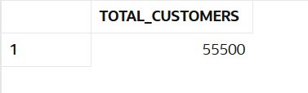

-- Count distinct customer IDs
SELECT COUNT(DISTINCT CUST_ID) AS distinct_customer_ids
FROM SH.CUSTOMERS;

OUTPUT
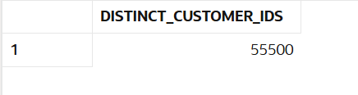

-- Profiling
------------------------------------------------------------
-- Customers grouped by marital status
SELECT CUST_MARITAL_STATUS, COUNT(*) AS customer_count
FROM SH.CUSTOMERS
GROUP BY CUST_MARITAL_STATUS
ORDER BY customer_count DESC;

OUTPUT
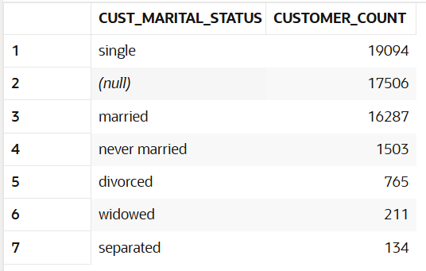

-- Customers grouped by income level
SELECT CUST_INCOME_LEVEL, COUNT(*) AS customer_count
FROM SH.CUSTOMERS
GROUP BY CUST_INCOME_LEVEL
ORDER BY customer_count DESC;

OUTPUT
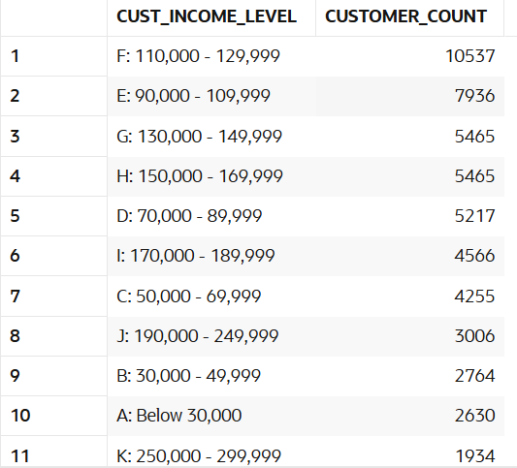
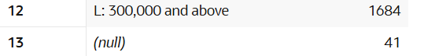

-- NULL Value Checks
SELECT
SUM(CASE WHEN CUST_FIRST_NAME IS NULL THEN 1 ELSE 0 END) AS null_first_name,
SUM(CASE WHEN CUST_LAST_NAME IS NULL THEN 1 ELSE 0 END) AS null_last_name,
SUM(CASE WHEN CUST_EMAIL IS NULL THEN 1 ELSE 0 END) AS null_email,
SUM(CASE WHEN CUST_INCOME_LEVEL IS NULL THEN 1 ELSE 0 END) AS null_income_level
FROM SH.CUSTOMERS;

OUTPUT
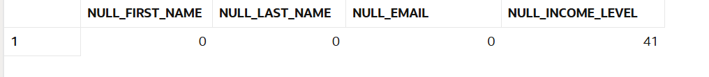

-- Replace missing income level with 'Unknown'
UPDATE SH.CUSTOMERS
SET CUST_INCOME_LEVEL = 'Unknown'
WHERE CUST_INCOME_LEVEL IS NULL;

-- Insights
------------------------------------------------------------
--Distribution by Gender
SELECT CUST_GENDER, COUNT(*) AS customer_count
FROM SH.CUSTOMERS
GROUP BY CUST_GENDER
ORDER BY customer_count DESC;

OUTPUT
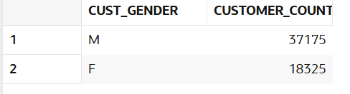

-- Age Segmentation
SELECT
FLOOR((EXTRACT(YEAR FROM SYSDATE) - CUST_YEAR_OF_BIRTH)/10)*10 AS age_group,
COUNT(*) AS customer_count
FROM SH.CUSTOMERS
GROUP BY FLOOR((EXTRACT(YEAR FROM SYSDATE) - CUST_YEAR_OF_BIRTH)/10)*10
ORDER BY age_group;

OUTPUT
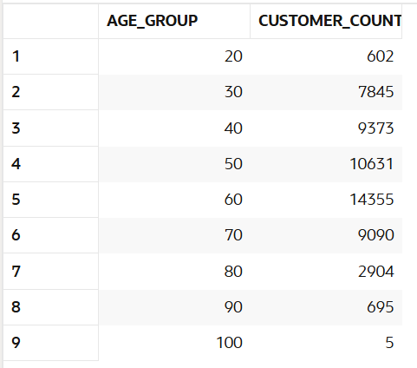

-- Average credit limit by income level
SELECT CUST_INCOME_LEVEL, AVG(CUST_CREDIT_LIMIT) AS avg_credit_limit
FROM SH.CUSTOMERS
GROUP BY CUST_INCOME_LEVEL
ORDER BY avg_credit_limit DESC;

OUTPUT
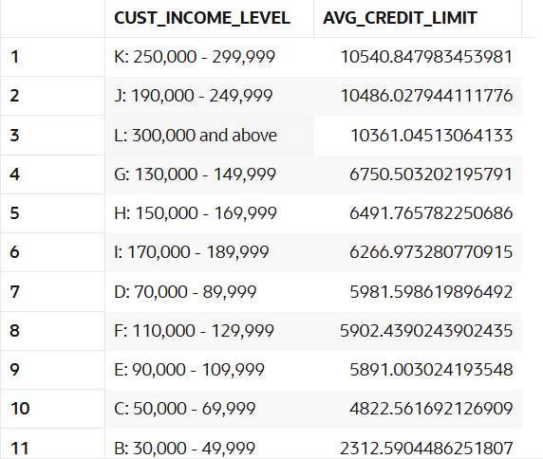
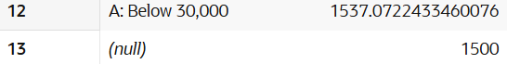

-- Top 10 customers with highest credit limit
SELECT CUST_ID, CUST_FIRST_NAME, CUST_LAST_NAME, CUST_CREDIT_LIMIT
FROM SH.CUSTOMERS
ORDER BY CUST_CREDIT_LIMIT DESC
FETCH FIRST 10 ROWS ONLY;
OUTPUT
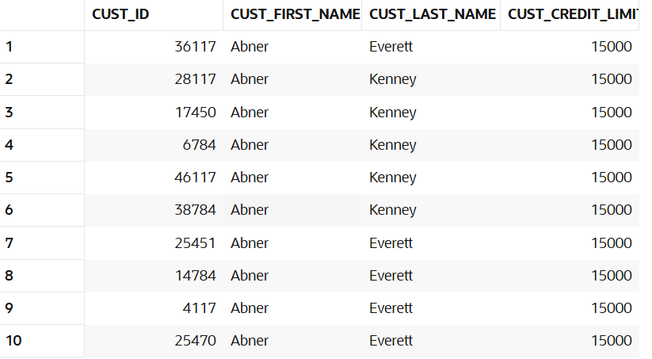

------------------------------------------------------------
-- Relationships with Tables
------------------------------------------------------------
-- Sales by customer income level
SELECT c.CUST_INCOME_LEVEL, SUM(s.AMOUNT_SOLD) AS total_sales
FROM SH.SALES s
JOIN SH.CUSTOMERS c ON s.CUST_ID = c.CUST_ID
GROUP BY c.CUST_INCOME_LEVEL
ORDER BY total_sales DESC;

OUTPUT
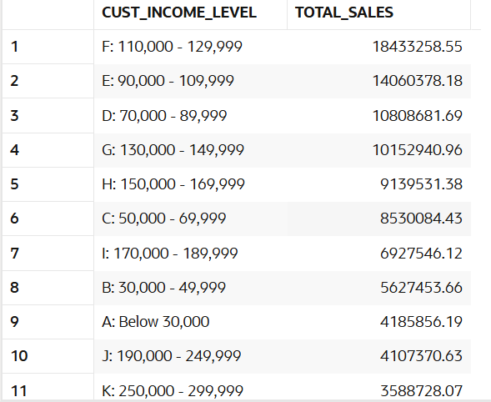

-- Customers by Country
SELECT co.COUNTRY_NAME, COUNT(*) AS customer_count
FROM SH.CUSTOMERS cu
JOIN SH.COUNTRIES co ON cu.COUNTRY_ID = co.COUNTRY_ID
GROUP BY co.COUNTRY_NAME
ORDER BY customer_count DESC;

OUTPUT
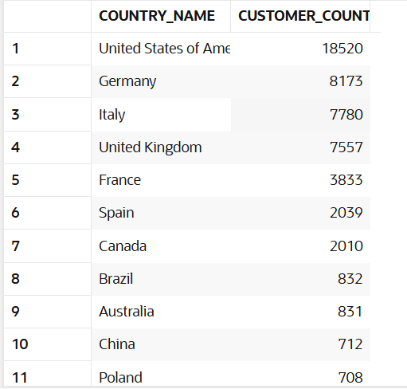
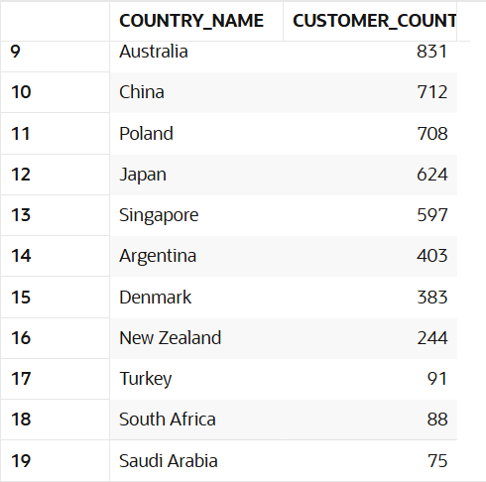

-- Spending by Age Group
SELECT
FLOOR((EXTRACT(YEAR FROM SYSDATE) - cu.CUST_YEAR_OF_BIRTH)/10)*10 AS age_group,
SUM(s.AMOUNT_SOLD) AS total_spent
FROM SH.SALES s
JOIN SH.CUSTOMERS cu ON s.CUST_ID = cu.CUST_ID
GROUP BY FLOOR((EXTRACT(YEAR FROM SYSDATE) - cu.CUST_YEAR_OF_BIRTH)/10)*10
ORDER BY age_group;

OUTPUT
